|  |
| --- |
|  |
| User Manual  Rotary Youth Driving Awareness (User) |
| **Creation date: 9/22/2017** |
|  |
|  |
|  |

This user manual is for the Rotary Youth Driving Awareness (RYDA) Quiz system. All the screenshots are captured using Google Chrome (Version 55). Compatibility test was done on Google Chrome, Internet Explorer (Edge) and Safari. Test result is satisfactory. Application can run on any version of the browser.

Table of Contents

1. Software Architecture 3

2. Layer Modelling 4

3. Database Design 5

4. Class modelling 6

4.1. Class diagram of JPA Entities 20

4.2. Class diagram of EJBs 21

4.3. Class diagram of backing beans 22

5. User Interface Design 23

5.1. Quiz Main page’s 23

5.2. Admin Interface 26

6. Behaviour Modelling 30

6.1. SD1 – Login 30

6.2. SD2 – Create Quiz 30

6.3. SD3 – Edit Quiz 30

6.4. SD4 – Delete Quiz 30

6.5. SD5 – List Quiz 30

6.6. SD6 – View Quiz 30

6.7. SD7 – Create Question 30

6.8. SD8 – Edit Question 30

6.9. SD 9 – Delete Question 30

6.10. SD10 – List Question 30

6.11. SD11 – View Question 30

6.12. SD12 – Logout 30

6.13. SD13 – Attempt Quiz 30

7. Requirement Mapping 31

# Home page

* Open the browser Firefox, Chrome, IE or Safari
* Enter the url: <http://localhost:8080/RYDA>
* User will see the arrow facing down to follow to next page. (Figure 1)

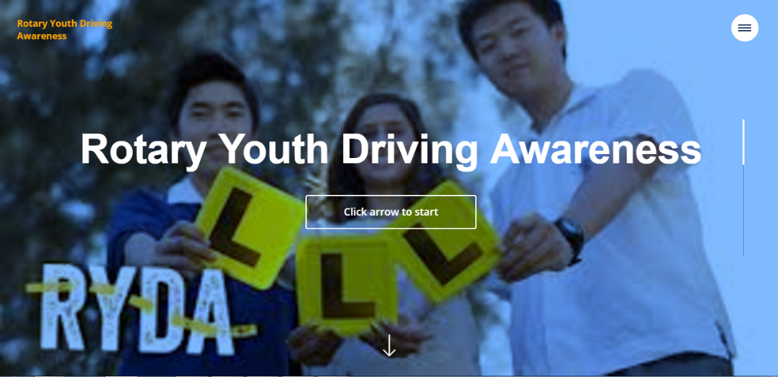

**Fig 1. Home Page**

# Personal detail form

* Fill in the form with personal detail and continue to the next page by clicking in the arrow facing down (Figure 2)

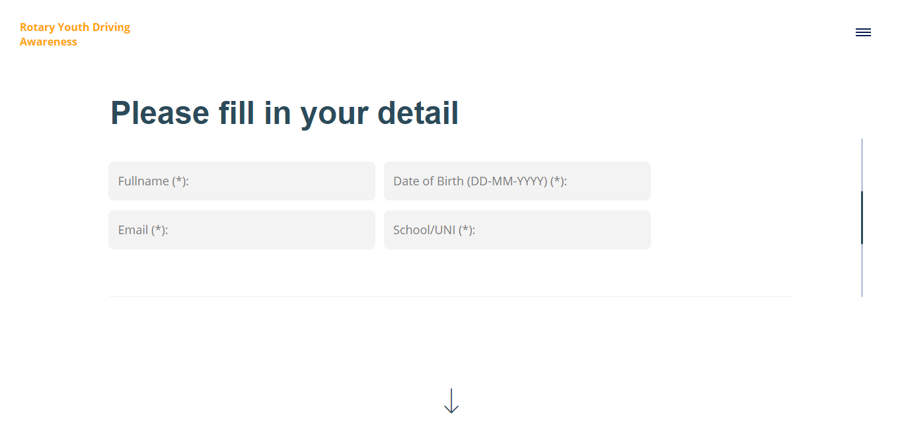**Fig 2. Personal detail form**

# Select listed quiz

* Displays the list of quiz available
* Select the quiz that user want to attempt (Figure 3)

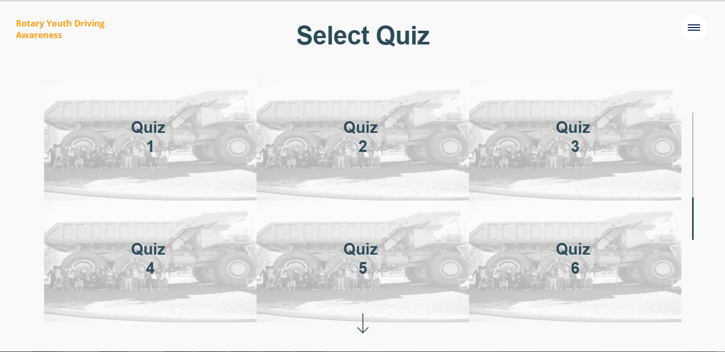

**Fig 3. Quiz List**